## DIFFERENCE BETWEEN SP AND FUCNTION

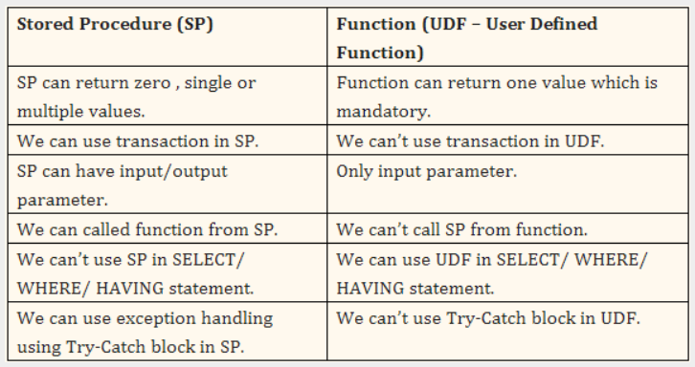

## PREDICATES

Is an expression that evaluates to TRUE, FALSE, or UNKNOWN.

Predicates are used in the search condition of WHERE clauses and HAVING clauses, the join conditions of FROM clauses, and other constructs where a Boolean value is required. For example, ISNULL (), EXISTS (), CONTAINS () etc.

## UNION VS UNION ALL

**UNION:** Combines the results of two or more queries into a single result set that includes all the rows that belong to all queries in the union. The UNION operation is different from using joins that combine columns from two tables. Union operator removes the duplicate records from the result set.

The number and the order of the columns must be the same in all queries and the data types must be compatible

**UNION ALL:** operator is used to combine the result sets of 2 or more SELECT statements. It does not remove duplicate rows between the various SELECT statements (all rows are returned).

Each SELECT statement within the UNION ALL must have the same number of fields in the result sets with similar data types.

ORDER BY should be used after performing UNION/ UNION ALL of the datasets in consideration.

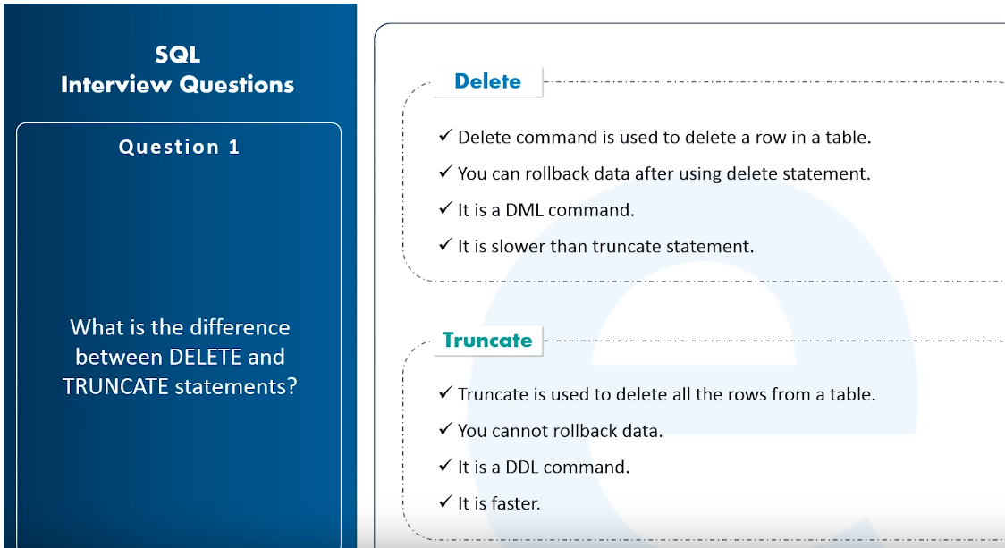

## T - SQL SUB SET

**DML:** DML is abbreviation of Data Manipulation Language. It is used to retrieve, store, modify, delete, insert and update data in database.

Examples: SELECT, UPDATE, INSERT, DELETE statements

**DDL:** DDL is abbreviation of Data Definition Language. It is used to create and modify the structure of database objects in database.

Examples: CREATE, ALTER, DROP, TRUNCATE statements

**DCL:** DCL is abbreviation of Data Control Language. It is used to create roles, permissions, and referential integrity as well it is used to control access to database by securing it.

Examples: GRANT, REVOKE statements

**TCL:** TCL is abbreviation of Transactional Control Language. It is used to manage different transactions occurring within a database.

Examples: COMMIT, ROLLBACK statements

## TO FIND NTH HIGHEST SALARY

We can either use subquery or we can use dense_rank fucntion.

